COMPUTER NETWORK LAB PROJECT

For

HOTEL NETWORK CONFIGURATION

Version 1.0

Prepared by

Hafiz Muhammad Zubair (196-BSSE-5D)

Submitted to

Sir Rasikh Ali

Department of Software Engineering,

Superior University, Lahore.

December, 2024

Introduction

This project entails the design and configuration of a comprehensive network infrastructure tailored for a hotel environment, utilizing Cisco Packet Tracer. The network setup encompasses various elements including serial router configurations, password security measures and DHCP implementation to streamline IP address management.

Objective

The primary aim of this project is to develop a robust and efficient network infrastructure customized to meet the specific demands of a hotel setting. This involves the creation of segmented VLANs to manage traffic effectively, configuring routers to enable inter-VLAN communication, implementing security measures such as password protection, deploying a web server to facilitate guest services, and integrating DHCP services for simplified IP address allocation.

Description of System:

Admin Office: Located on the first floor, Router 1 serves as the gateway for this area. It is responsible for managing network traffic and providing internet access to administrative devices.

Reception Area: Connected to the Admin Office, this area is the focal point for guest interactions. Devices in the reception area connect to the Admin Office router for network services.

Marketing Department (First Floor): Router 2 is connected to this department, applying STICK VLAN segmentation to isolate its network traffic. It ensures efficient communication within the marketing department while maintaining security.

IT Department (First Floor): Also connected to Router 7, the IT department has its STICK VLAN to separate its network operations. This setup allows the IT team to manage their resources independently.

Second Floor and Third Floor: These floors follow a similar network setup as the first floor, with routers connecting to the central router (Router 2) for internet access and STICK-VLAN communication.

Server Room: Located on the third floor, Router 3 connects this critical area to the central router. It ensures that servers hosting essential hotel services are accessible to all relevant departments while maintaining security measures.

Network Topology

The network topology comprises the following components:

1. Routers: Facilitate interconnection between VLANs and provide gateway access to the internet.
2. Switches: Serve to connect devices within each VLAN segment.
3. PCs: Representing guest devices including laptops, smartphones.
4. Web Server: Hosts essential services such as guest portal, room service requests, etc.
5. DHCP Server: Facilitates automatic IP address assignment to network devices.

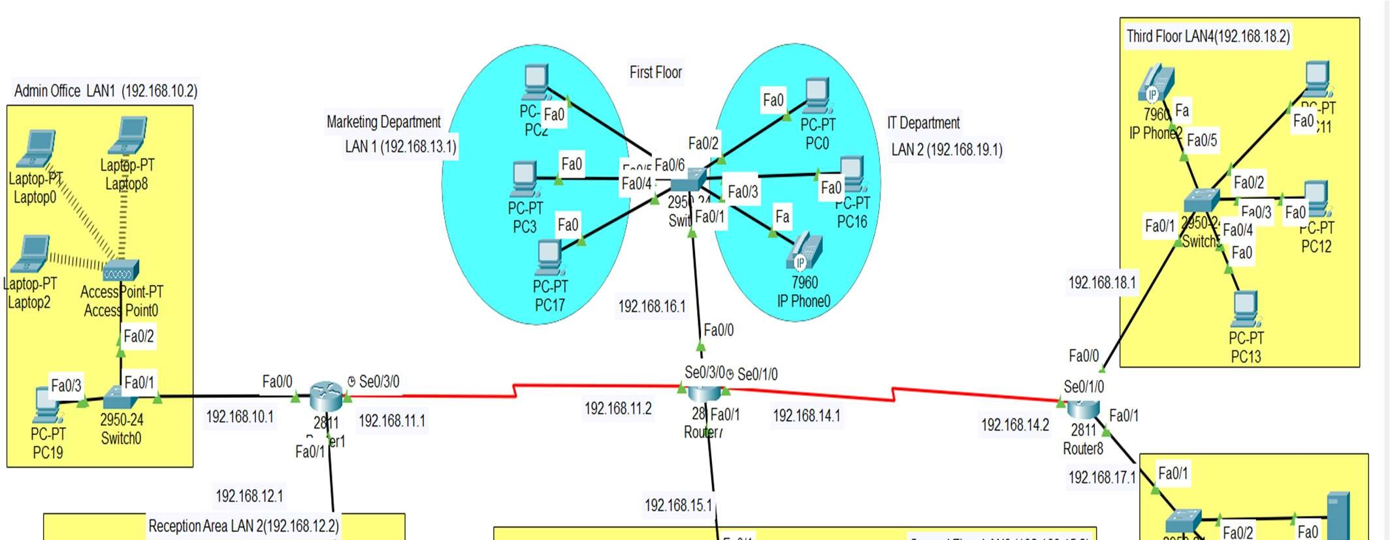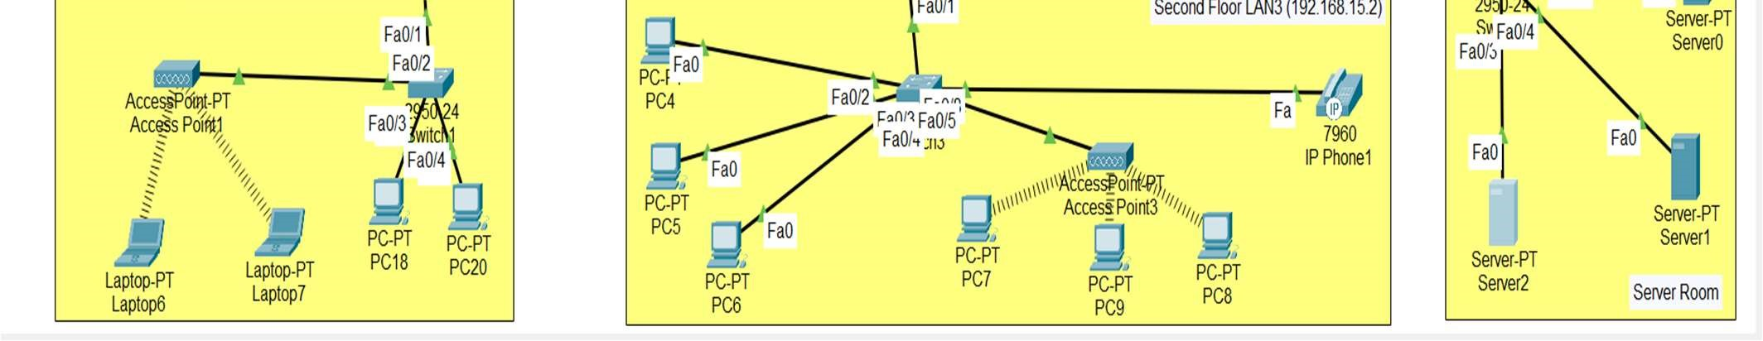

Configuration Details

* 1. Serial Router Configuration

Router 1

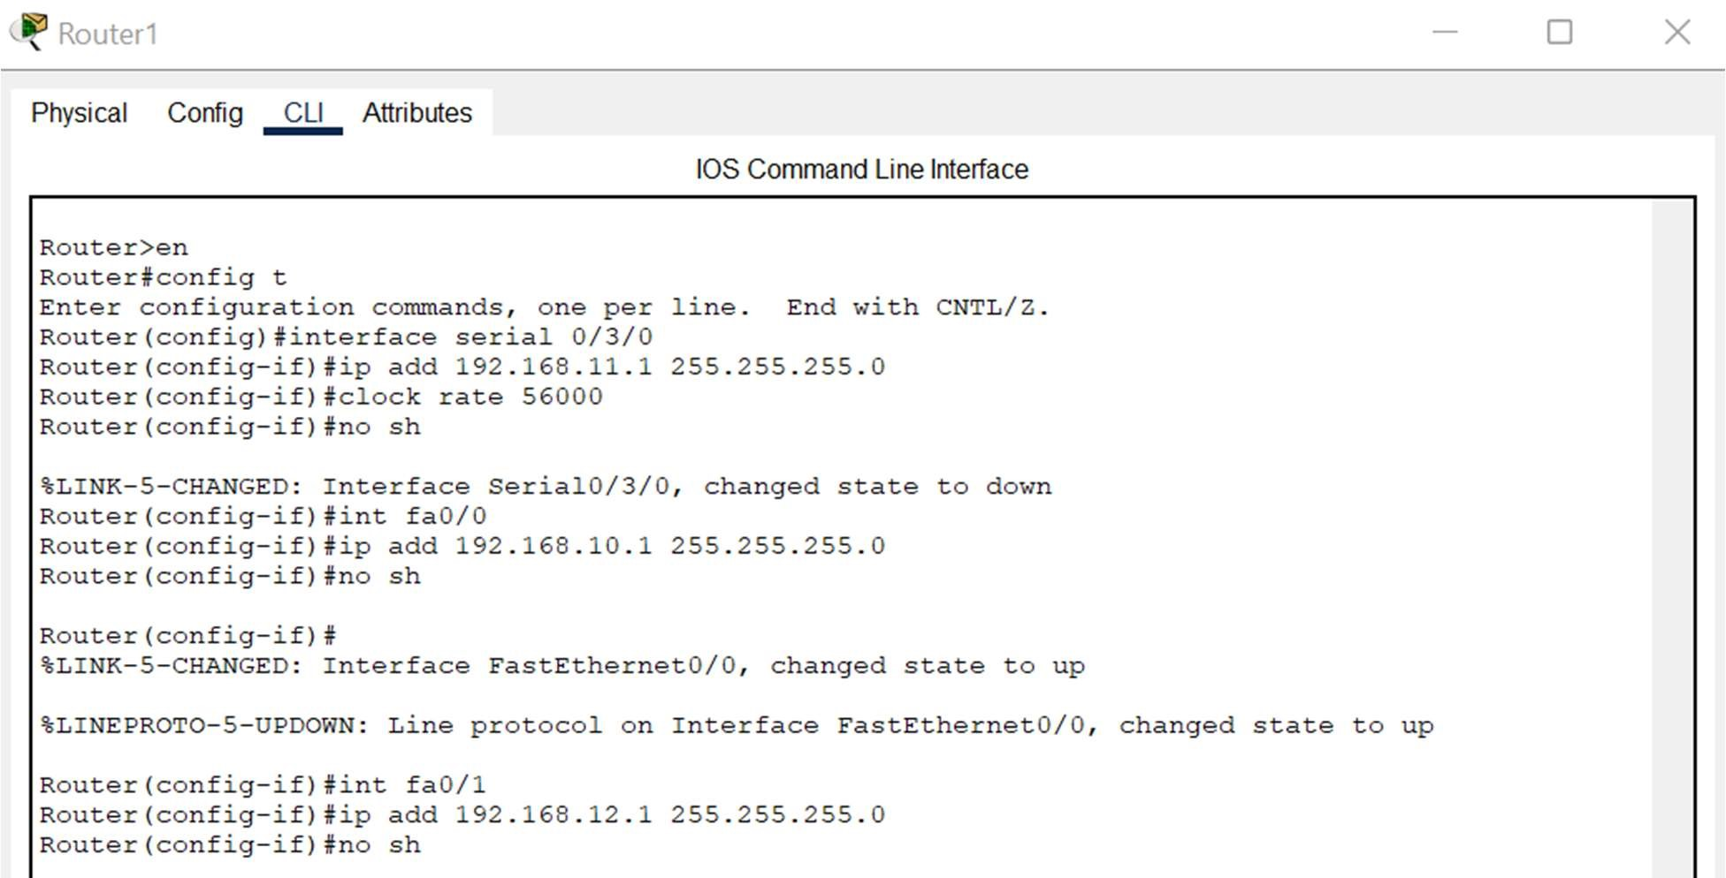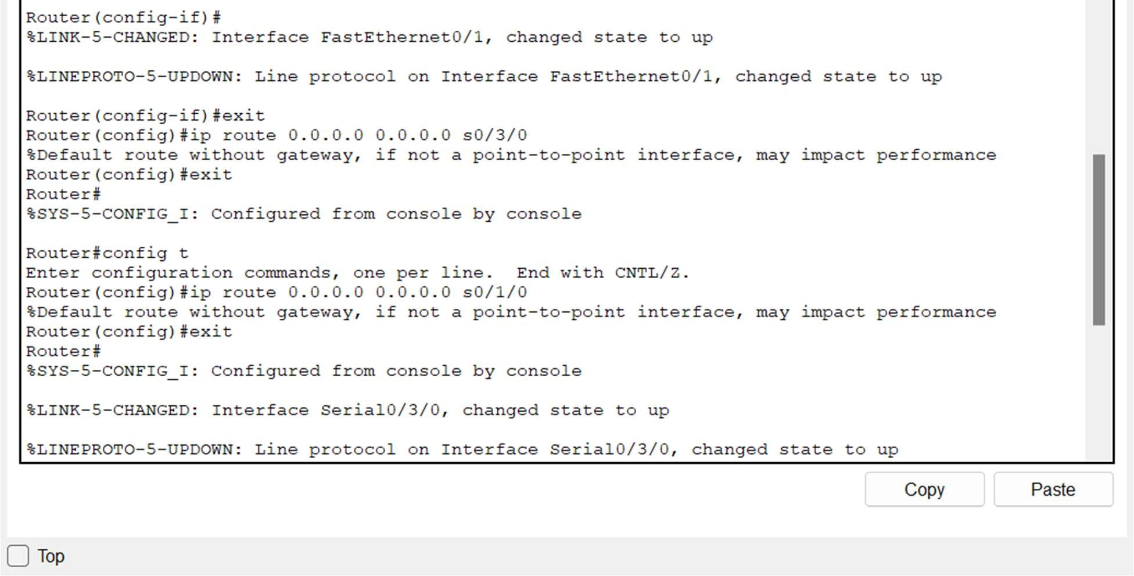

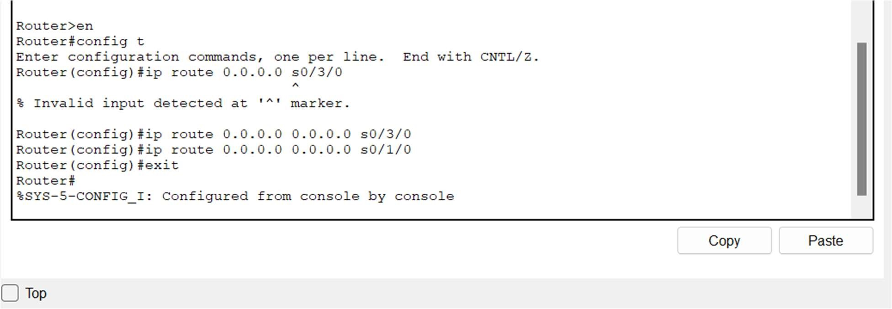

Router 2

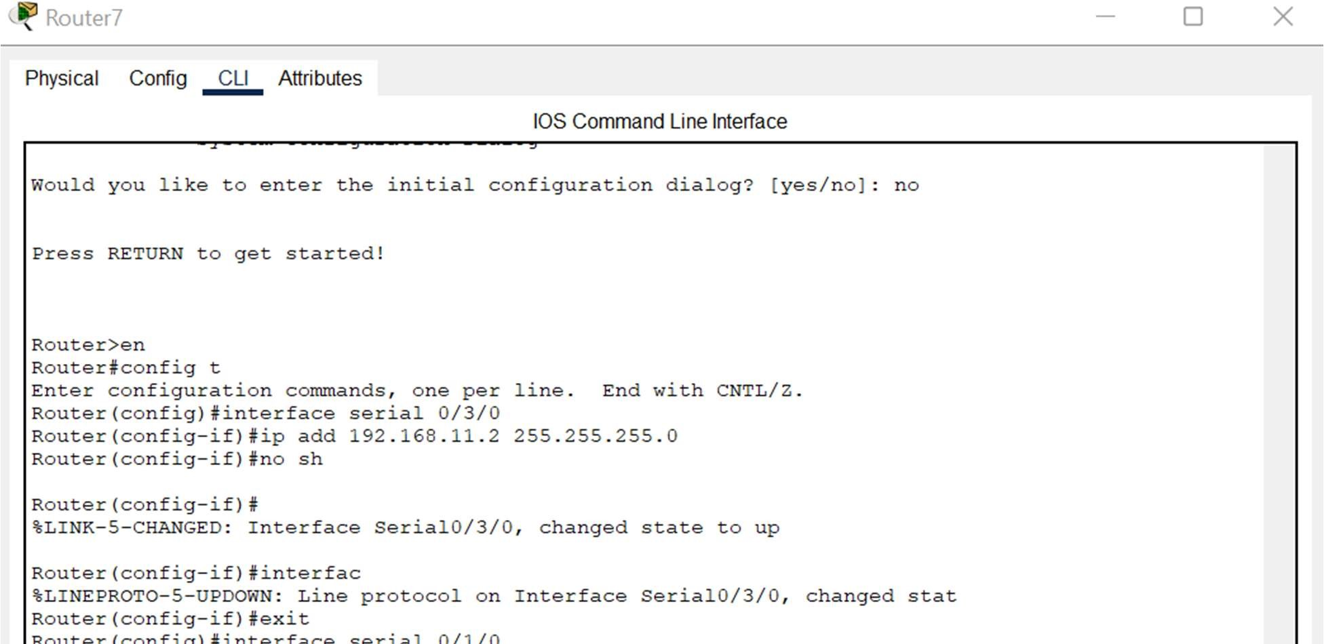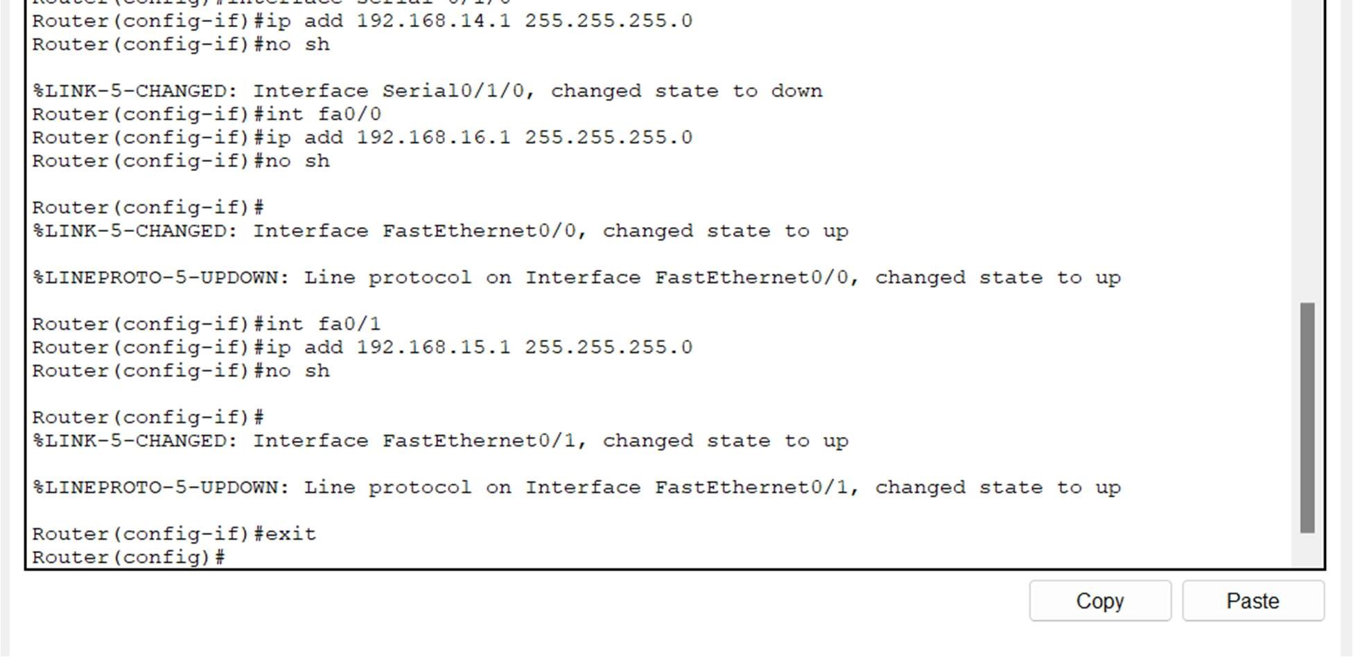

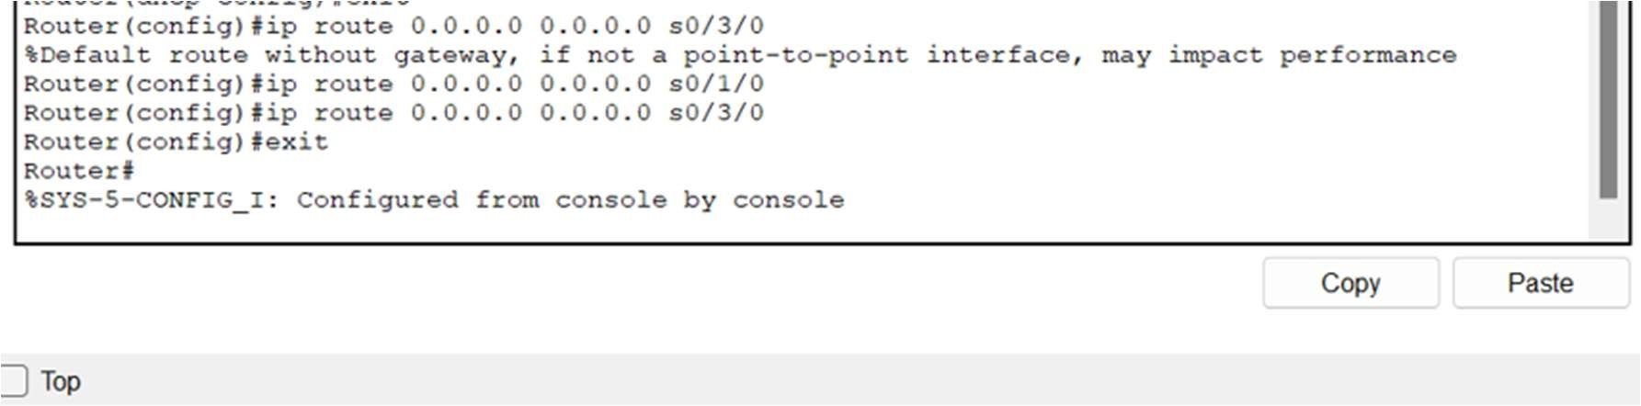

Router 3

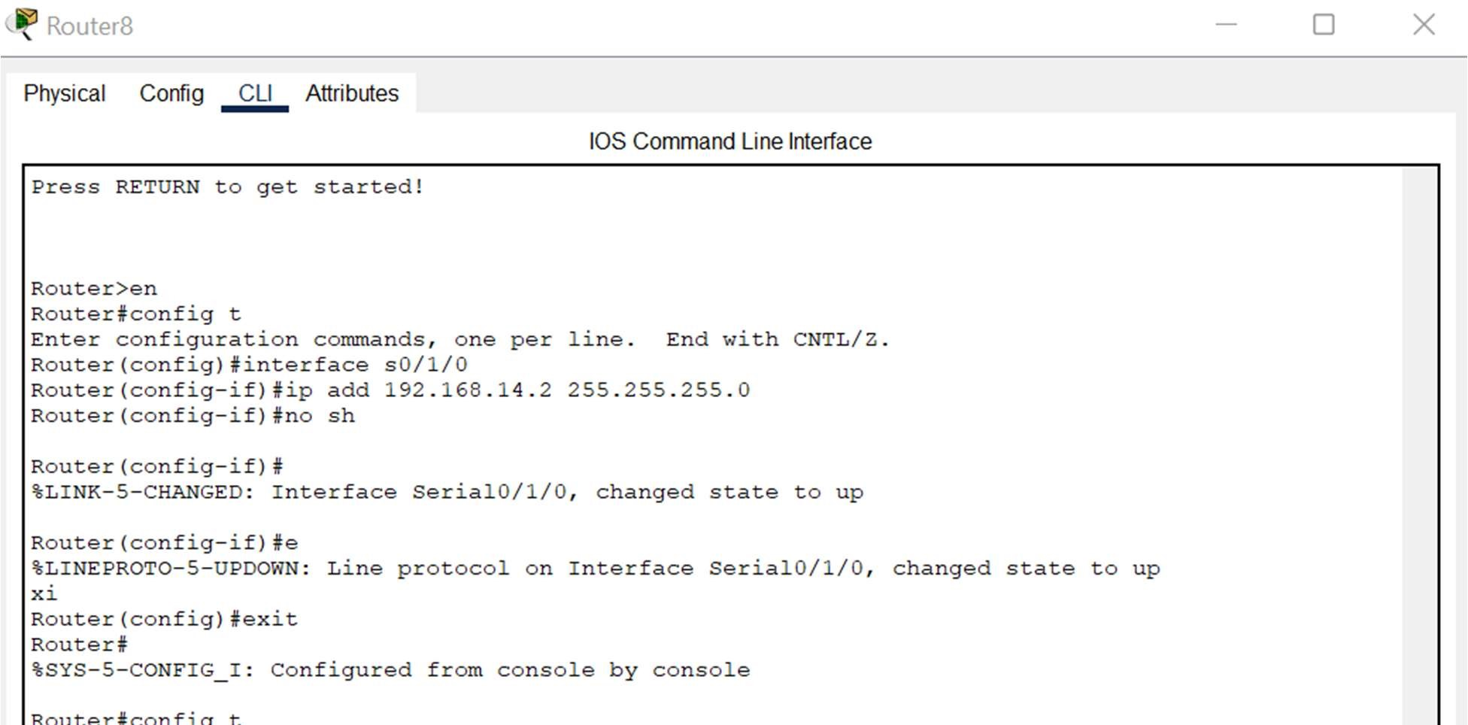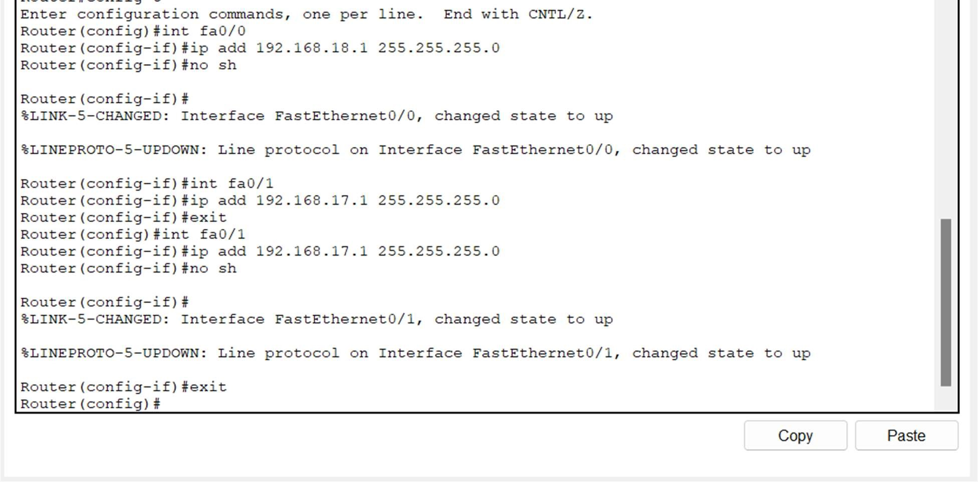

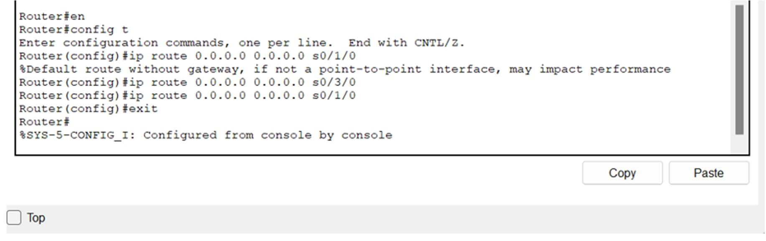

* 1. Stick VLAN Implementation

Switch

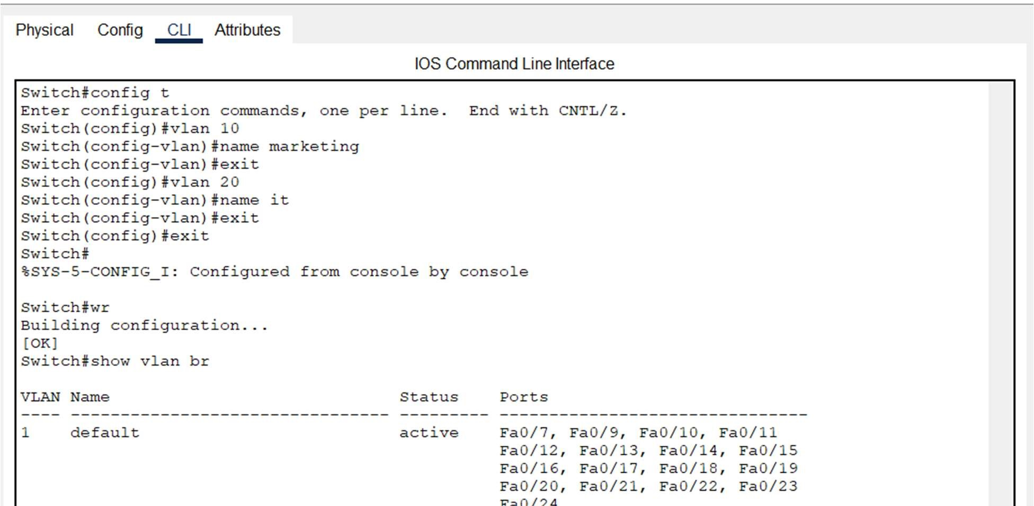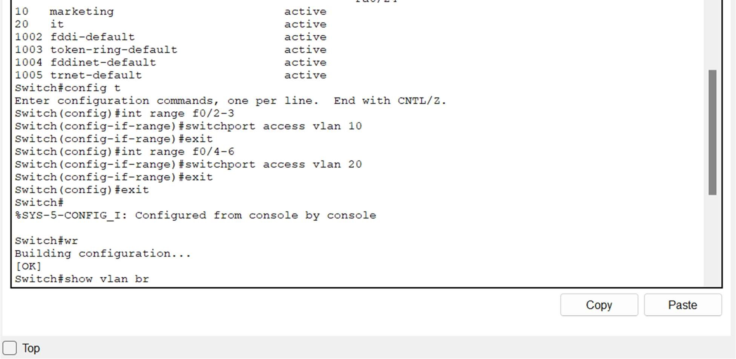

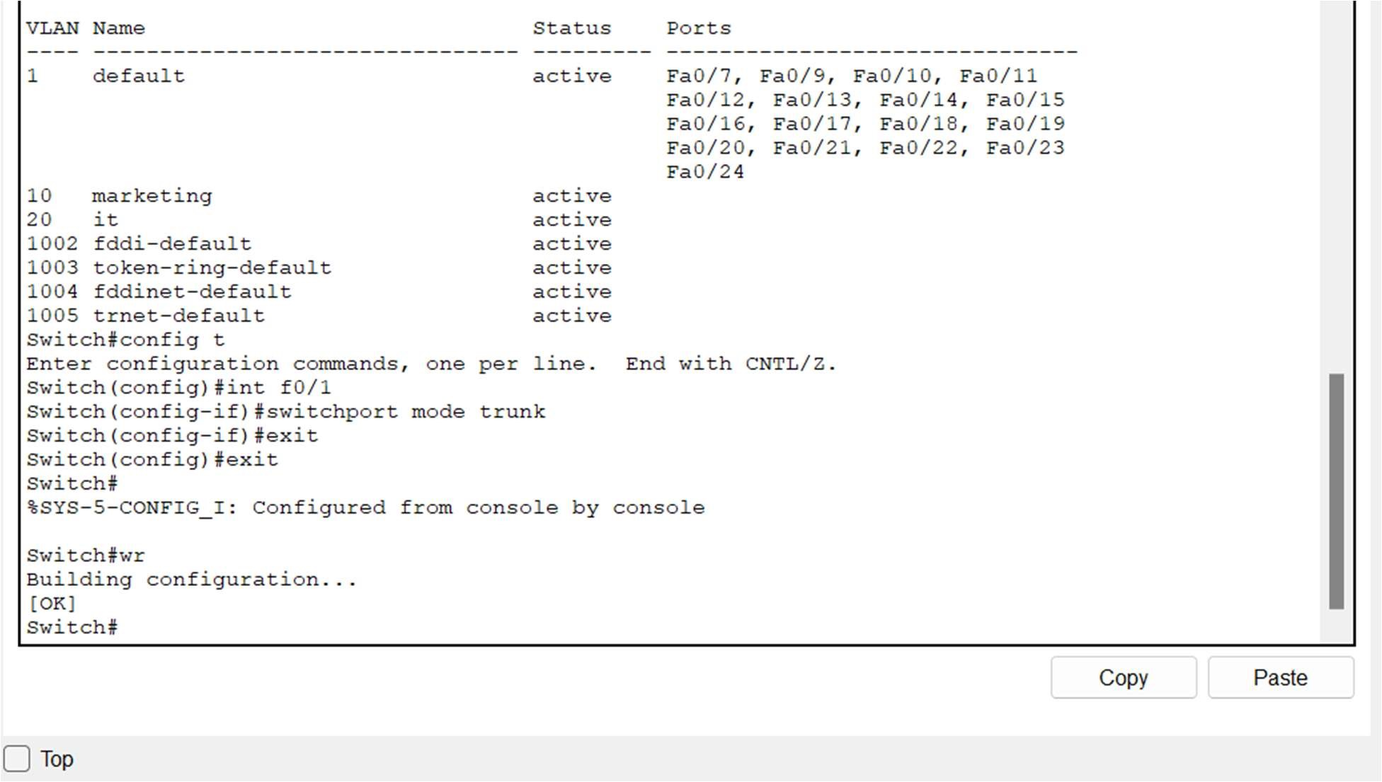

Router 2

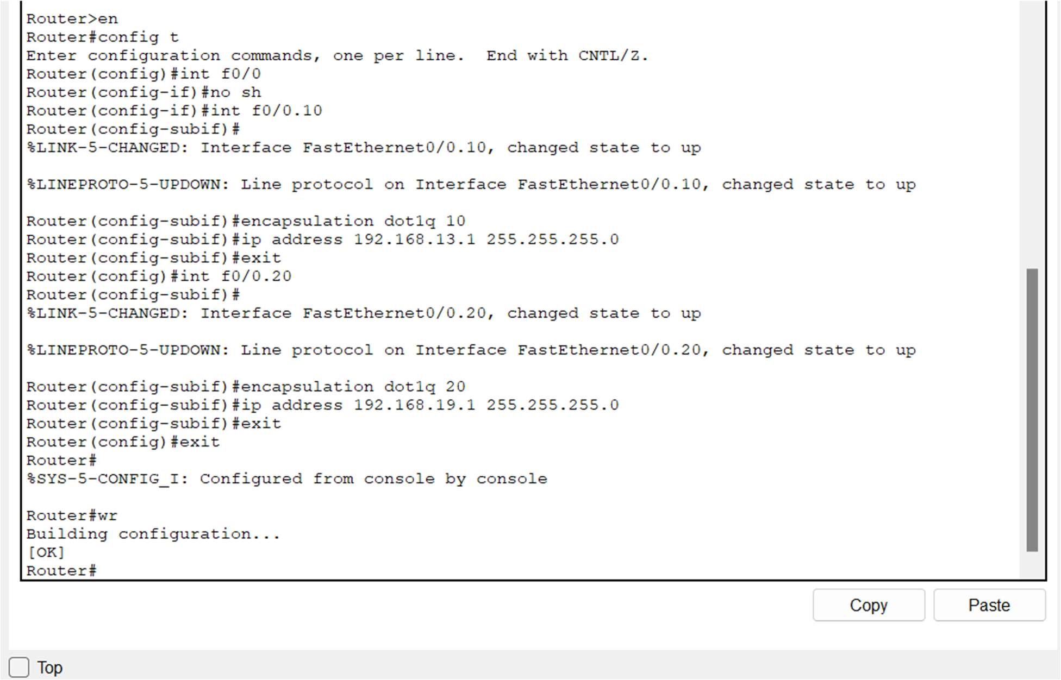

* 1. Password Setting

Admin Office

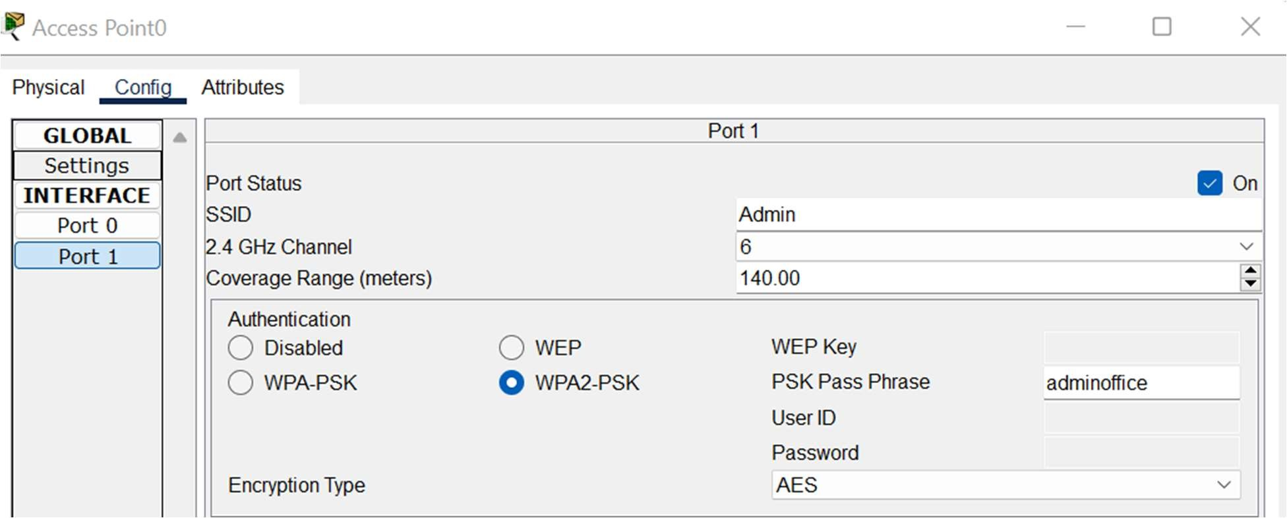

Reception Area

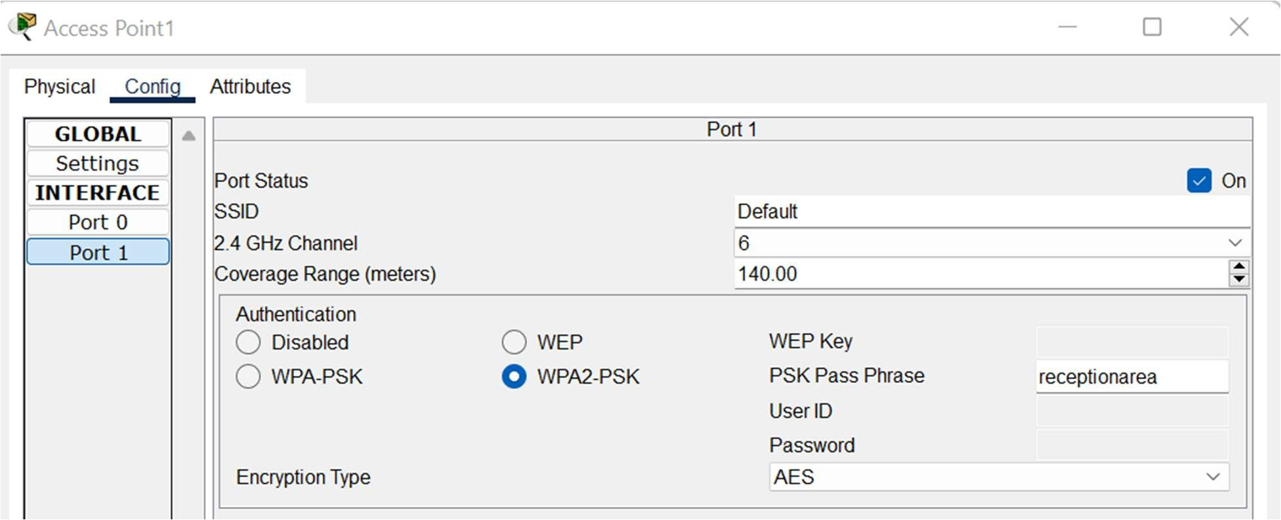

Second Floor

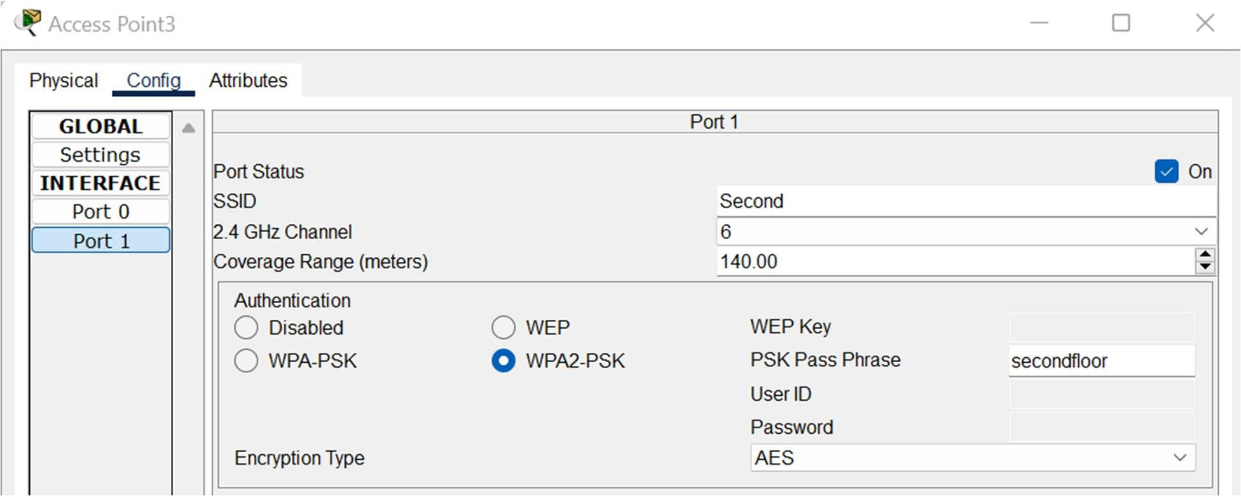

* 1. DHCP Implementation

Router 1

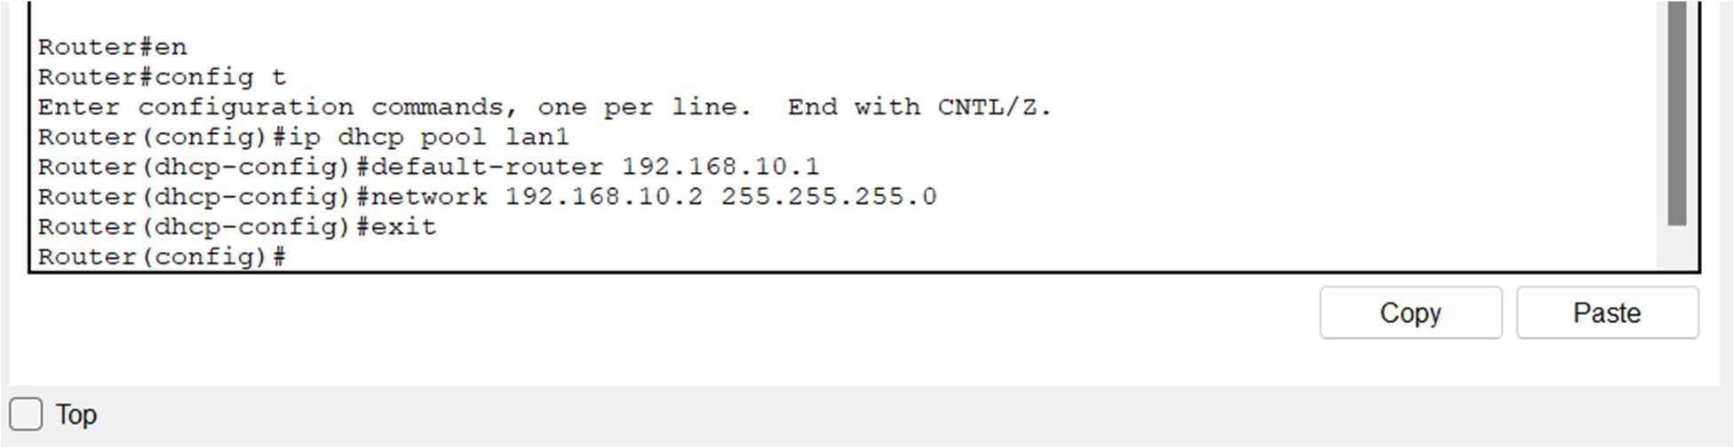

Router 2

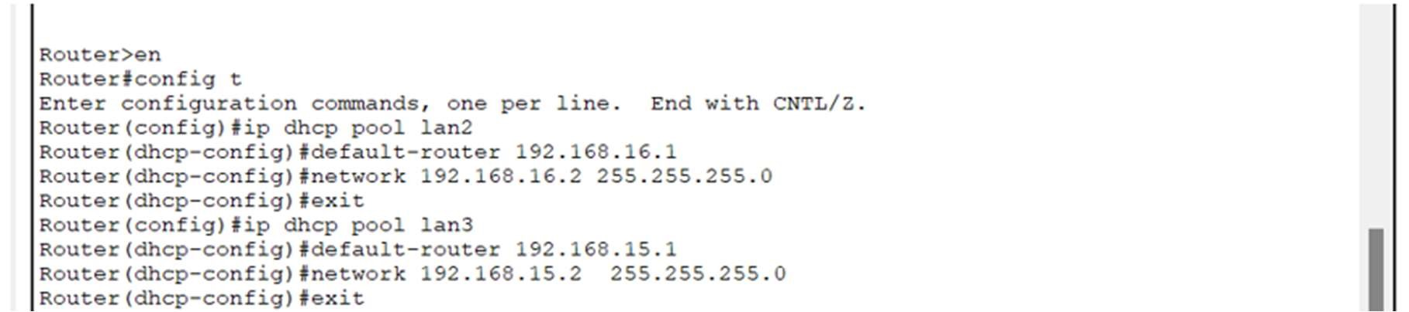

Router 3

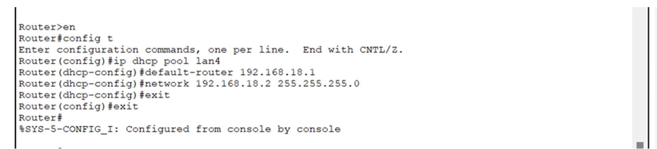

Conclusion

By implementing this network infrastructure, the hotel ensures efficient communication, robust security, and seamless access to essential services for guests and staff. The segmented STICK VLAN, DHCP, Passwords and routing configuration, facilitate smooth operations across different departments while maintaining network integrity and security.